vOffice User Guide
This user guide is intended for users who already have vOffice access. Please note that vOffice access is not enabled by default and must be requested through IT Service Catalog.

Note: Please skip this step if you already have enrolled your mobile device and the Microsoft Authenticator is installed.

If not, you are requested first to complete the enrollment for Multi-Factor Authentication (MFA) using the guides below:
- iOS M365 Enrollment Guide
- Android M365 Enrollment Guide
Windows Devices:
  - Using your computer at the office while connected to ADIB network through Wi-Fi or cable, please follow instructions in section 1/A (click here)
  - Using your computer from Home:
    - On Personal Computer, please follow instructions in section 1/B (click here)
    - On ADIB Computer, please follow instructions in section 1/B starting from point 9 (click here)

Section 1: Windows Devices
- Using your computer at the office
- From the Start menu, search for Citrix then open Citrix Workspace  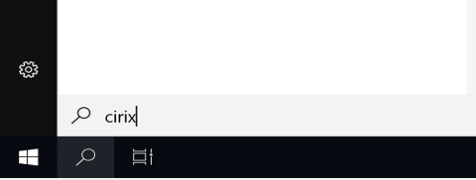  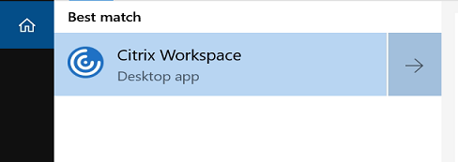  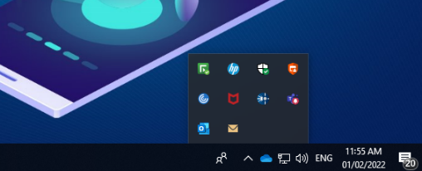  3. To open all business applications, click the Citrix Workspace 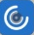 from the taskbar within vOffice | - Click on vOffice icon to launch the Desktop  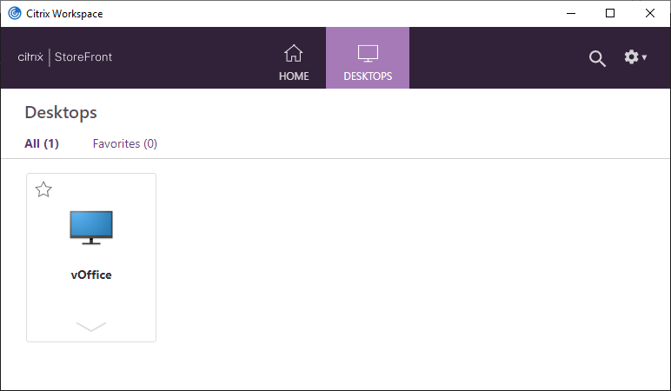  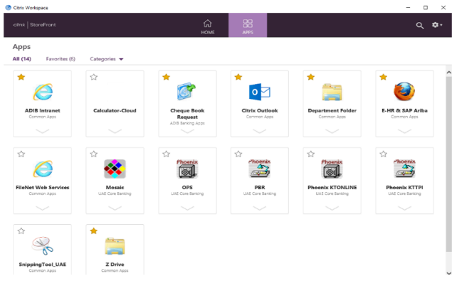
- Using your computer from Home
  - Install Citrix Workspace App
If you already have Citrix Workplace app installed, skip this step and procced to point 9.
  - From Internet Browser, go to https://www.citrix.com/products/receiver.html
  - Click on Download for Windows


  - Click on Download Citrix Workspace app for Windows

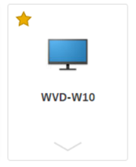
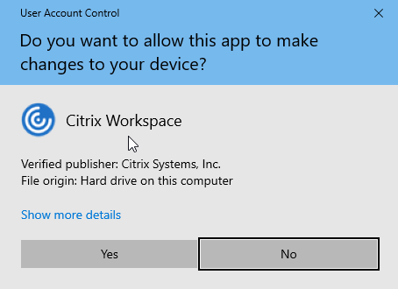
  - Once the download is completed, click on Open file under CitrixWorkspaceApp.exe then click Yes on User Account Control Windows.
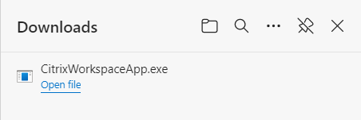
- On the Welcome to Citrix Workspace window, click Start |  | - On the License Agreement screen, check the box next to  I accept the license agreement then click Next
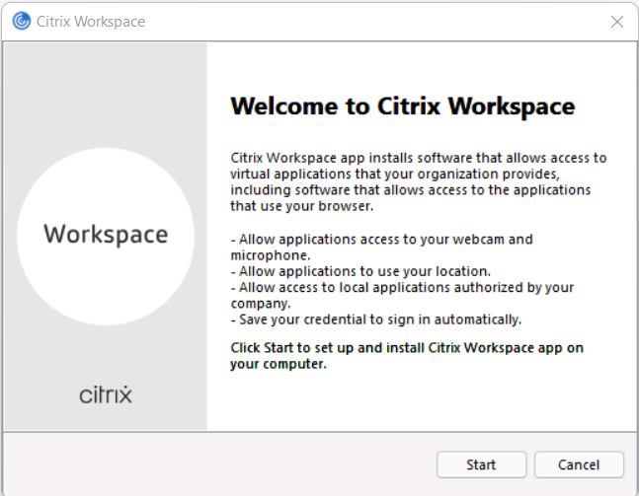 |  | 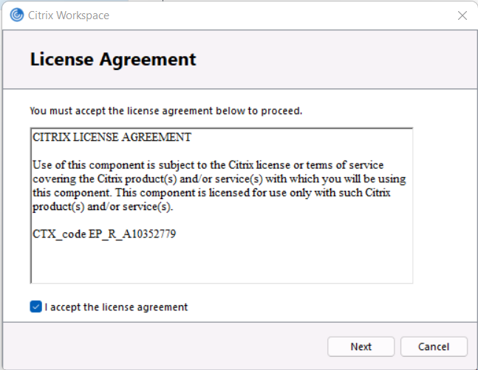
7. On the App protection window, click Install  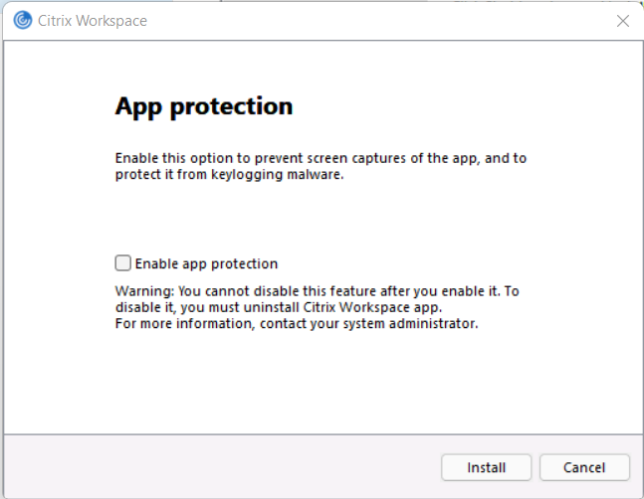 |  | 8. On the Installation successful window, click Finish  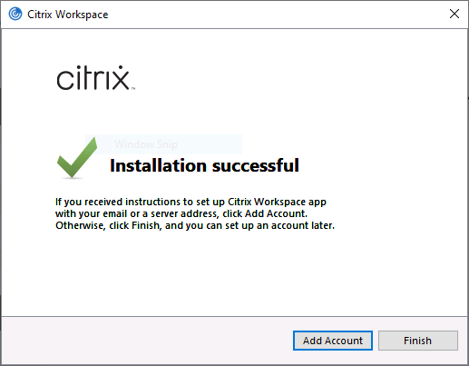
- Install Citrix Gateway End Point Analysis
  - Form your Internet browser, go to https://vOffice.adib.ae
  - Enter your ADIB email address then click Next
  - Enter your windows password then click Sign in
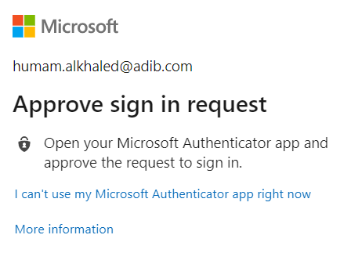
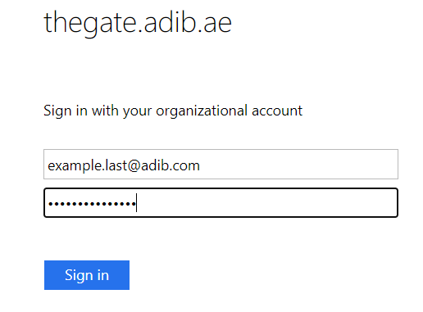
  - Open Microsoft Authenticator app on your mobile and approve the sign in request
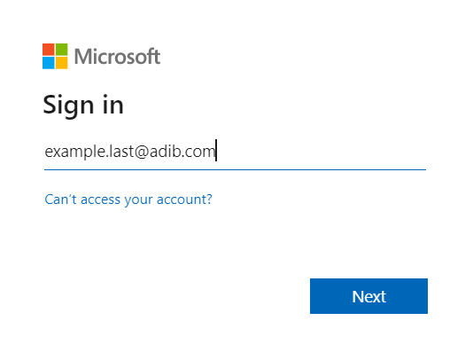
  - Click Download, then once the download is completed, click on Open file under nsepa_setup.exe and go through the installation instructions
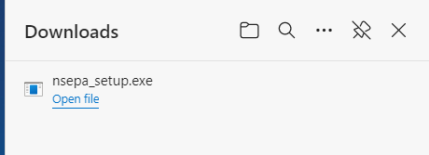
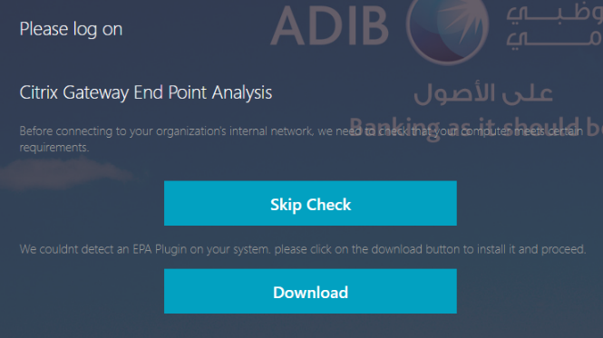

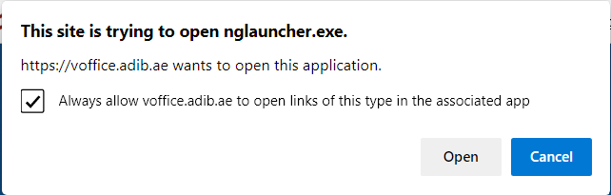
  - Go back to the browser, in the next pop-up windows
select Always allow voffice.adib.ae to open links
of this type in the associated app then click on Open
- In the Citrix Gateway windows, click on Always  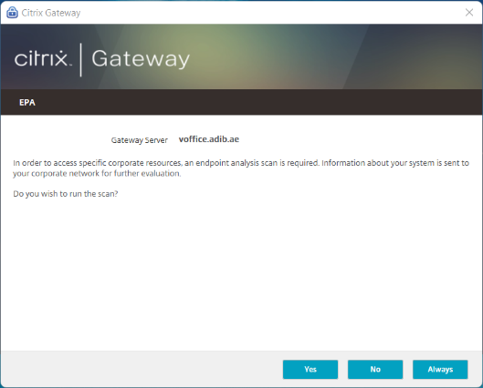 |  |  | 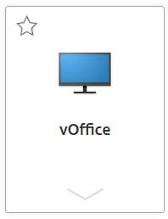  - Click on Desktops Tab then click on your vOffice icon to lunch the desktop
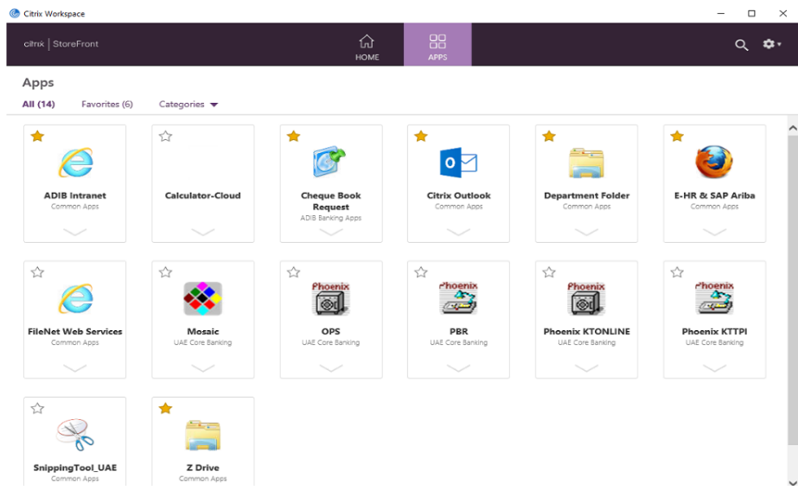
  - To open all business applications, click the Citrix Workspace from the taskbar within vOffice
